

Amour Box Design and Development Log

Report of Group 34

Queen Marry & BUPT

Liu Simeng, Li Liansheng, Li Xinlong, Du Yu,Li Yixin

Liu Yuhan, Li Wenzhuo, Zhu Bowen,

Yin Siyuan, Chen Yanda, Xu Zhiqiao

2016.7.4 - 2016.9.26

Introduction

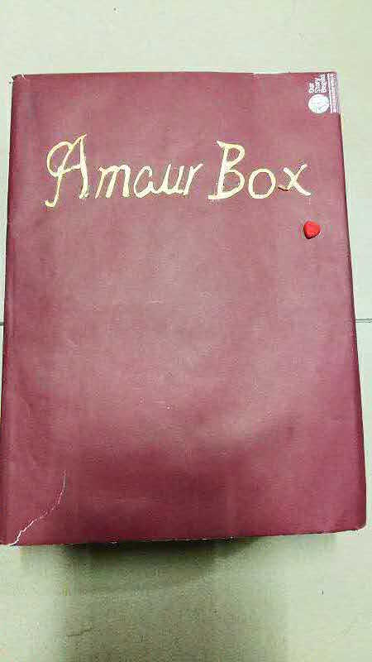Amour Box is a digital music box protected by a password lock. Its charm lays in the moving song it plays conveying devotion to the love of your life.

Amour box can give your sweetheart a big surprise as a birthday or anniversary present. Don’t forget the password can be set as those memorable days you have.

Direction For Use

1. Enter the password you set, it will open automatically if you give the correct password. Otherwise, the box will stay still and play warning sound.
2. The box will be locked and enter into a self-protected state if you type in wrong passwords after three times, and cannot be used in one minutes.
3. The Amour box does not have a default password. Instead it will prompt users to set their own passwords as their preference. To set your passwords, please enter your password twice and it will prompt “successful”, which implies you have successfully set your password.
4. To reset your password, please enter “ \*\*\*\*\*\* ” and the old password in sequence. If it is correct, the system will then prompt users “please enter your new password”. Please enter your password twice and it will prompt “successful”, which implies you have successfully set your password.

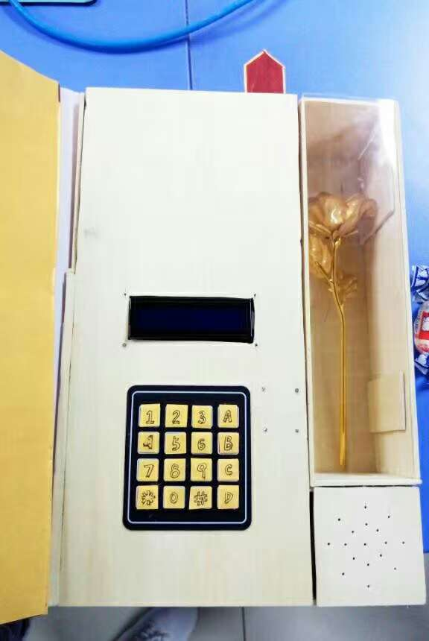

Common Request

1. The LCD displays nothing and the password keyboard does not have respond.

Solution: Check if the battery set is in good condition and installed correctly. You can change a set of battery to test.

1. Enter a wrong password and the music box stays locked.

Solution: Restart the music box, if the problem still exists, please contact our staff.

Reminder

YES:

· Read this note before use the Amour box.

· Keep the keyboard of the Amour box clean.

· Discontinue using if you felt dizzy.

NO：

· Amour box should avoid placing in damp environment, and do not set up sharp objects around to avoid accident.

· Do not use other manufacturers’ spare parts and accessories.

· Do not change the design of the elliptical machine.